|  |  |  |  |
| --- | --- | --- | --- |
| **Mobile Applications and Web Development -IS4904(Practical)** | | | |
| **Student Name: albandry alzhrani** | **Student ID:** | | **Section:** |
| **Assignment 8 (Flutter Application Development)** | | | |
| **Date: 5th May 2024** | | **Max Points:** | |

**Part 1:**

**Task: Reverse Engineering and Flowchart Creation**

**Objective**

The goal of this task is to enhance your understanding of reverse engineering and flowchart design. You will analyze a simple Flutter mini application (in the attachments) , identify its components, and create flowcharts to represent its processes.

**Instructions**

1. **Application Overview**:
   * You will receive a Flutter mini application (provided as an attachment).
   * Study the application carefully to understand its functionality, user interface, and behavior.
2. **Reverse Engineering**:
   * Reverse engineer the application by examining its code.
   * Identify the key components, such as widgets, state management, and navigation.
   * Understand how data flows within the app.
3. **Flowchart Creation**:
   * Create flowcharts to describe the following processes within the application:
     + The flow of data and processes.
     + How data will be processed and displayed

**Additional Notes**

* You can use any tool or software to create the flowcharts (e.g., draw.io, Lucidchart, pen and paper).
* Be concise and clear in your flowchart design.
* Consider edge cases and error handling in your analysis.

**Attachment**

Download the Flutter Mini Application

1. Input Process Flowchart:

+----------------+

| Start |

+----------------+

|

V

+----------------+

| Input Name |

+----------------+

|

V

+----------------+

| Input Age |

+----------------+

|

V

+----------------+

| Submit |

+----------------+

|

V

+----------------+

| Display |

| Message |

+----------------+

|

V

+----------------+

| End |

+----------------+

1. Data Processing and Display Flowchart

+----------------+

| Start |

+----------------+

|

V

+----------------+

| Get Name |

+----------------+

|

V

+----------------+

| Get Age |

+----------------+

|

V

+----------------+

| Format |

| Message |

+----------------+

|

V

+----------------+

| Display |

| Message |

+----------------+

|

V

+----------------+

| End |

|  |
| --- |
|  |

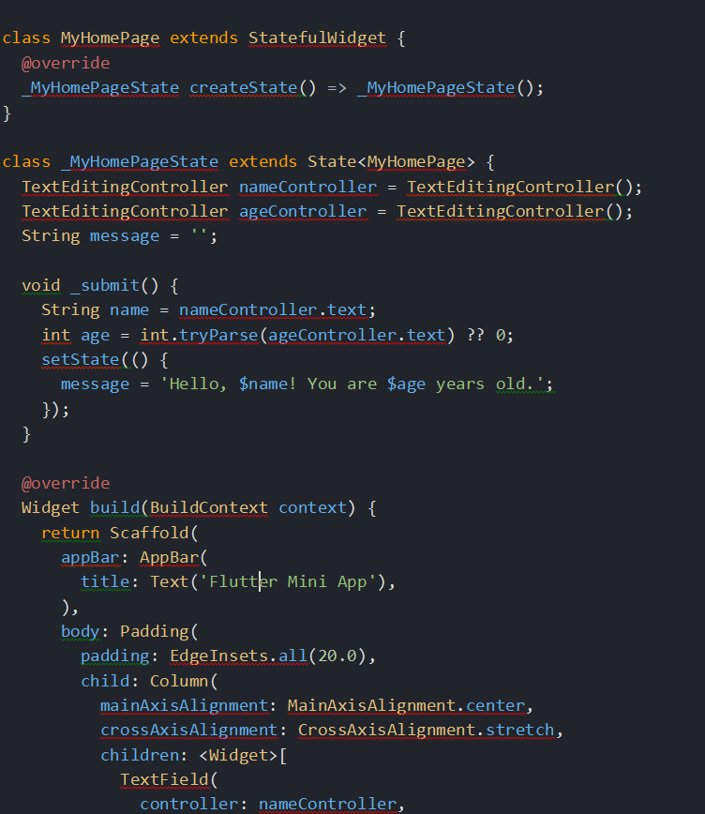

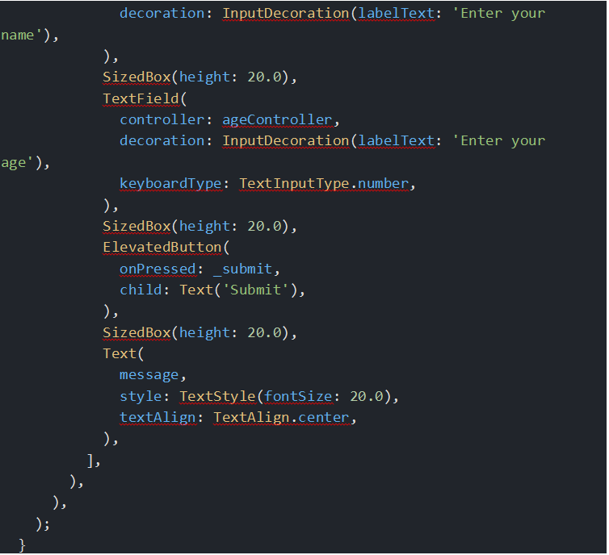

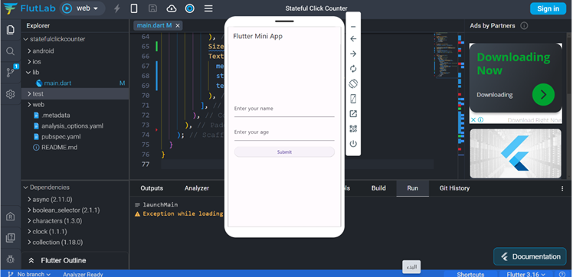

**Part II:**

**Task 1: Image Display and Random Order**

1. Create a **StatefulWidget** named ImageDisplayApp.
2. In the build method of the widget, display an image centered on the screen.
3. Initially, use the first image from the assets folder.
4. Add a button below the image.
5. When the user presses the button, change the displayed image to the next one in the sequence.
6. If the user reaches the last image, the image should cycle back to the first one.

**Task 2: Display Images in Random Order**

1. Reformat the code from Task 1.
2. Instead of displaying images sequentially, display them in a random order.
3. Every time the user presses the button, the images should shuffle randomly.

**Additional Notes**

* You need to add **five different images** to the assets folder.
* Make sure to handle the case when the user reaches the last image and it cycles back to the first one.

